AIM
Create a simple cloud software application and provide it as a service using any Cloud Service Provider to demonstrate Software as a Service (SaaS).
PROCEDURE
Step 1: Goto Zoho.Com
Step 2: Log In To Zoho.Com
Step 3: Select One Application
Step 4: Enter Application Name
Step 5: Created New Application
Step 6: Select One Form
Step 7: The Software Has Been Created.
OUTPUT
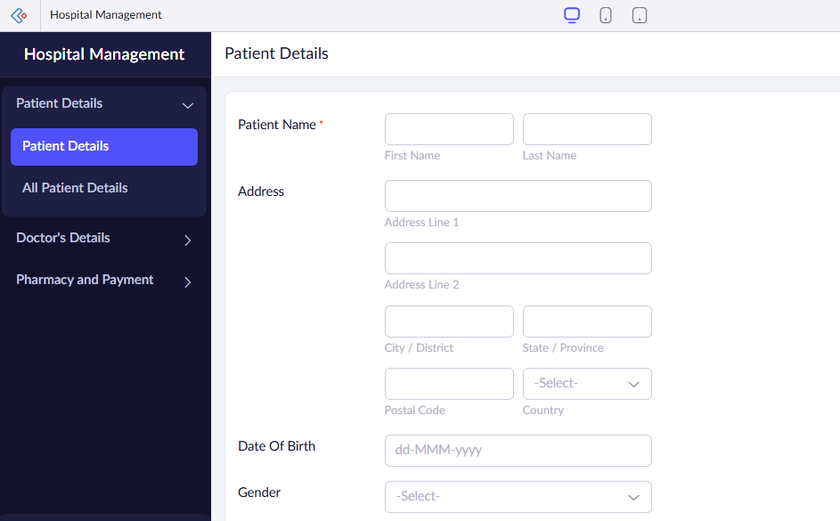
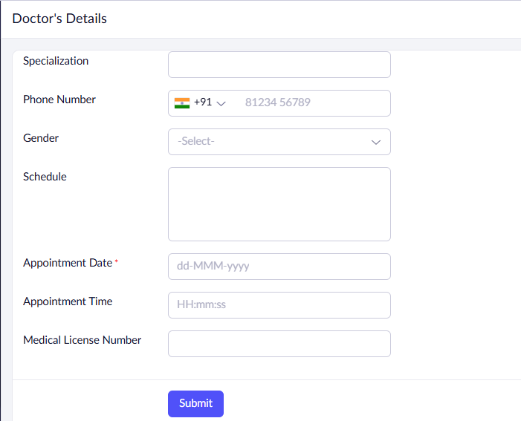
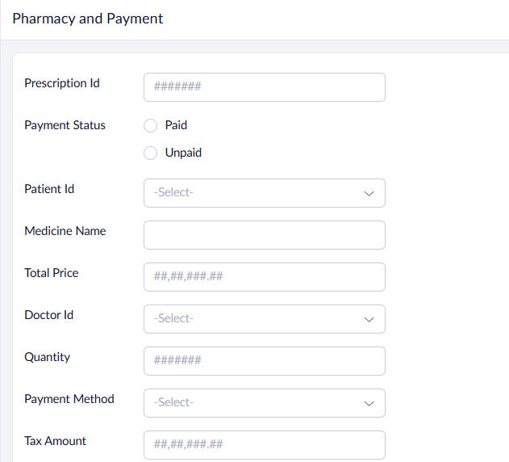
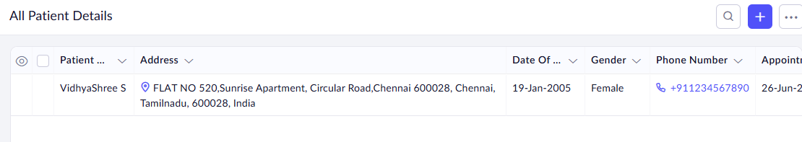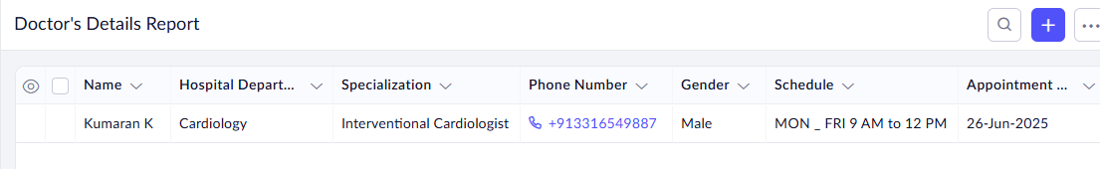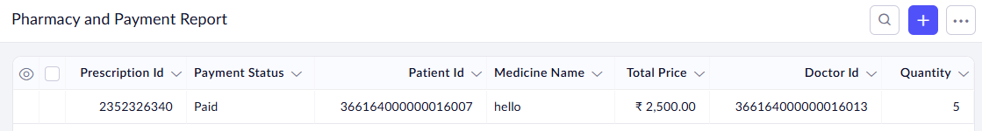
RESULT
Thus, the Hospital Management System is implemented using Zoho software

